PRAIRIE GARDEN AT LEE S. JONES PARK
Moira Miller, Lyon County Master Gardener

Phase 1 - In the spring of this year, Lyon County Judge Executive Wade White, asked the Lyon County Master Gardener Association (LCMGA) for assistance in landscaping the new Lyon Convention Center. Upon first examination, the prospect did not seem too hopeful. The planting beds in front of the building contained excess concrete and gravel to a depth of two feet. The first order of business was to remove this debris and then calculate just how much planting depth there was. Because the beds remained shallow, the LCMGA had quite a challenge deciding which plants to choose. The areas in question receive full sun in the afternoon, and we all know how hot our summers are. In addition, the plants needed to be drought-tolerant, deer-resistant, and low maintenance.

Master Gardener Deneise Tefft, suggested a Prairie Garden theme. The plan was to incorporate ornamental grasses, colorful perennials, and boulders for accent and interest. With White’s approval, a design was completed and plants ordered for installation in July. The county’s Parks Department readied the beds by adding a mixture of top soil, sphagnum moss, and compost.

Another Master Gardener, Don Robertson, was able to arrange the acquisition and delivery of large boulders. On July 6, all was ready and a group of Master Gardeners, park staff and female inmates planted over 150 plants. The installation of a drip irrigation system took place prior to mulching. Even though the plants used are drought-tolerant, they still needed a good watering until established. The real transformation was evident two months later when the plants had grown and filled in the area. Many residents have commented on how beautiful the area looks now.

Phase II – In September, the LCMGA began the second landscaping stage. This time it incorporated five raised areas between the driveways leading to the Lyon Convention Center. Continuing on the same Prairie Garden theme, the team planted 200 additional grasses and perennials, with an eye to color, texture, and height. The full effect of this phase will not be evident until next spring.

Many thanks to Wade White for giving the LCMGA the opportunity to work on this community project, and special thanks to Tom Peek, Bobby Williams, and the inmates of the Western Kentucky Correctional Complex for their assistance. The Lyon County Master Gardener Association’s main purpose is horticulture instruction. By collaborating on community projects such as Lee S. Jones Park, Eddyville Pavilion Scree Garden, and the new Eddyville sign, the LCMGA has been able to demonstrate landscaping techniques, illustrate site-specific plants, and educate residents about various ways to approach complex gardening challenges.

For a complete list of plants used on this project, go to the Lyon County Master Gardener Association website http://lcmga.yolasite.com/helpful-links.php. Educational programs of the Kentucky Cooperative Extension Service serve all people regardless of race, color, age, sex, religion, disability, or national origin.

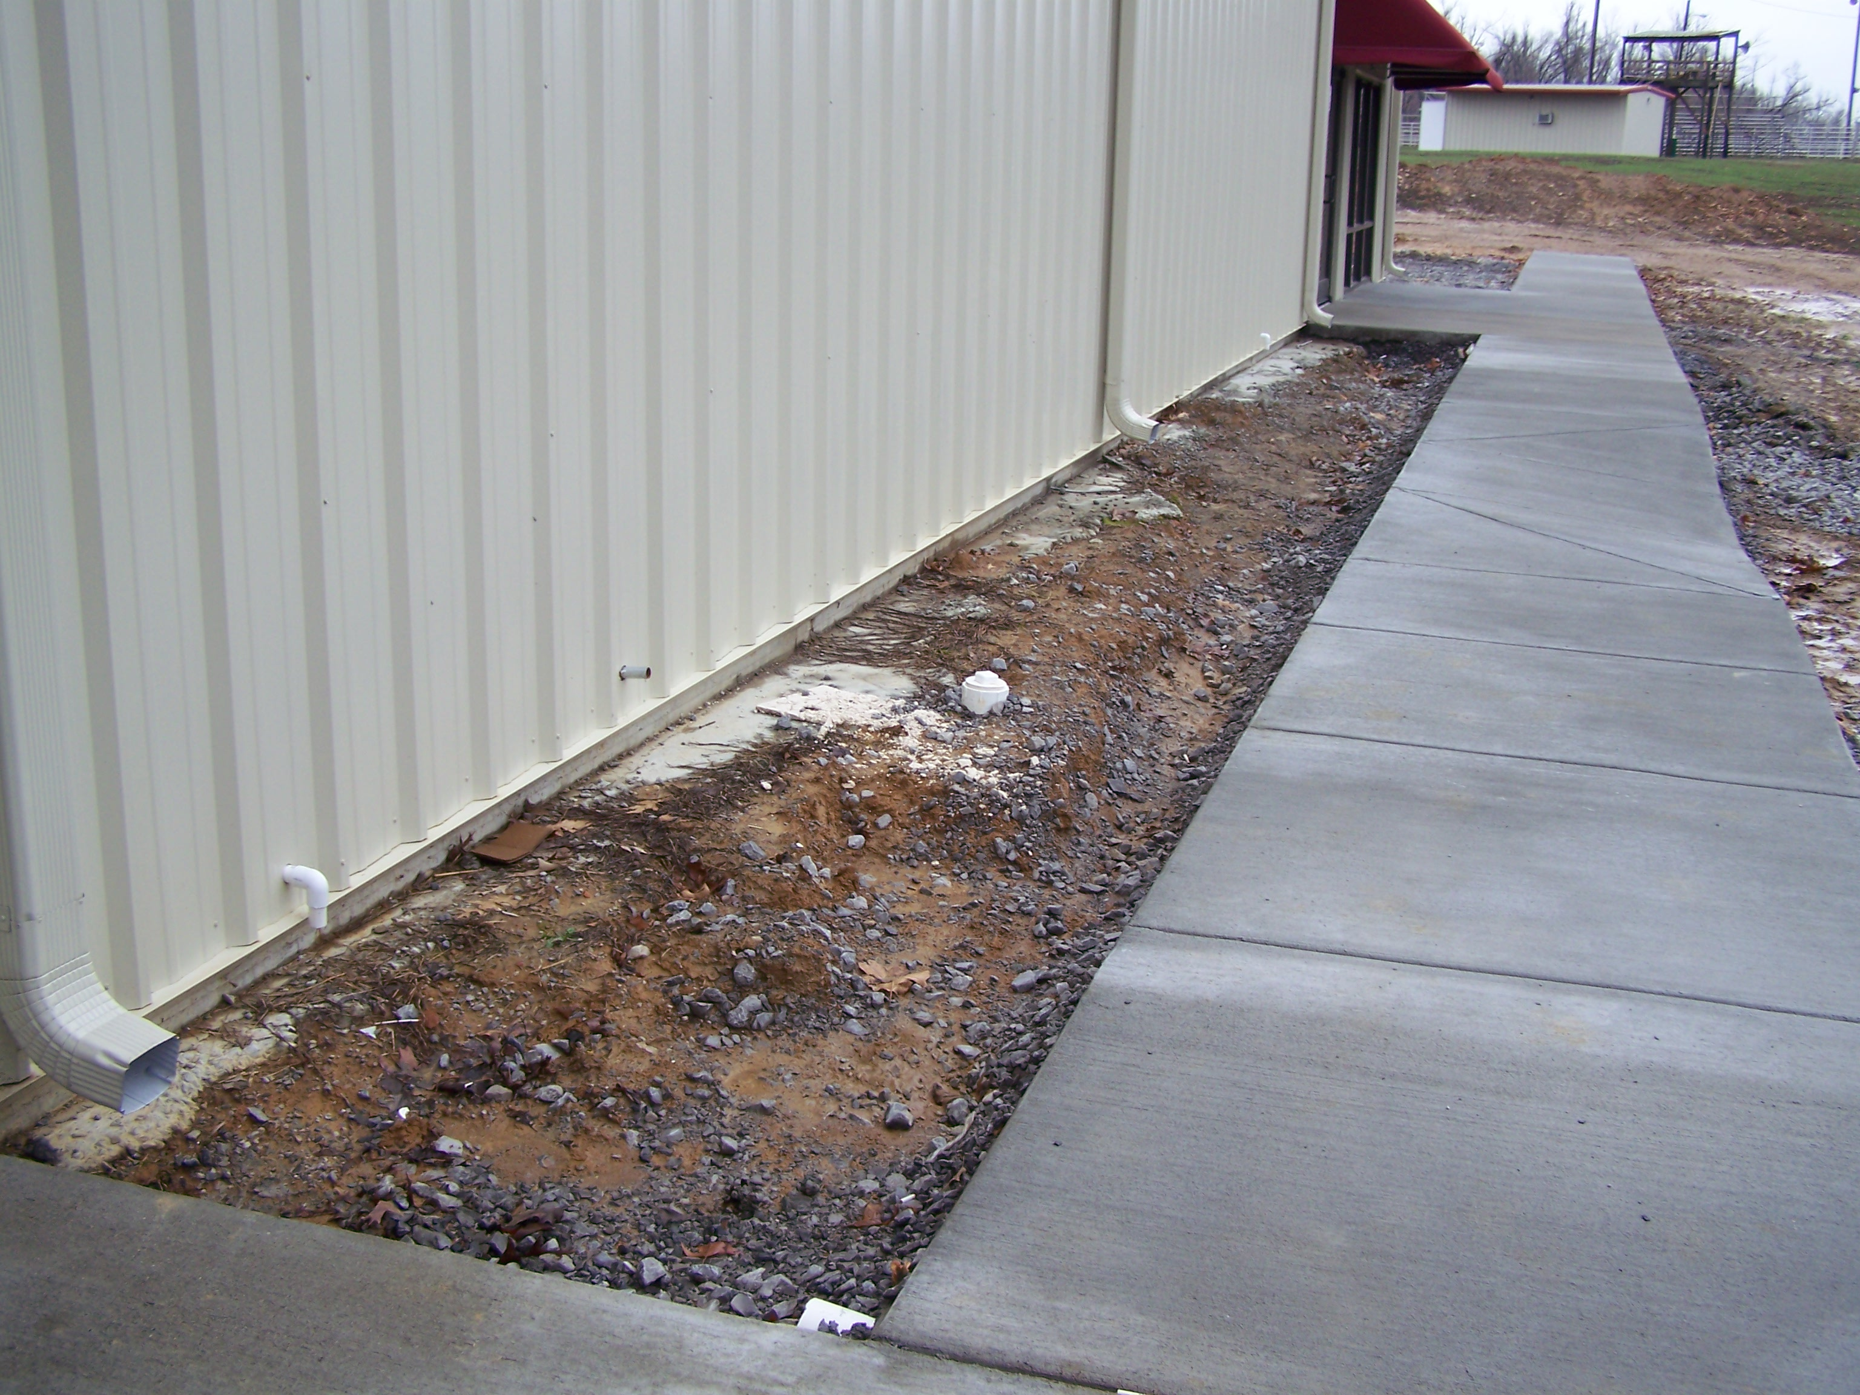
Spring 2011: Lee S. Jones Park – Lyon Convention Center. Shown - planting beds prior to Lyon County Master Gardeners’ starting the project. Note the concrete and gravel filling the space.

BEFORE

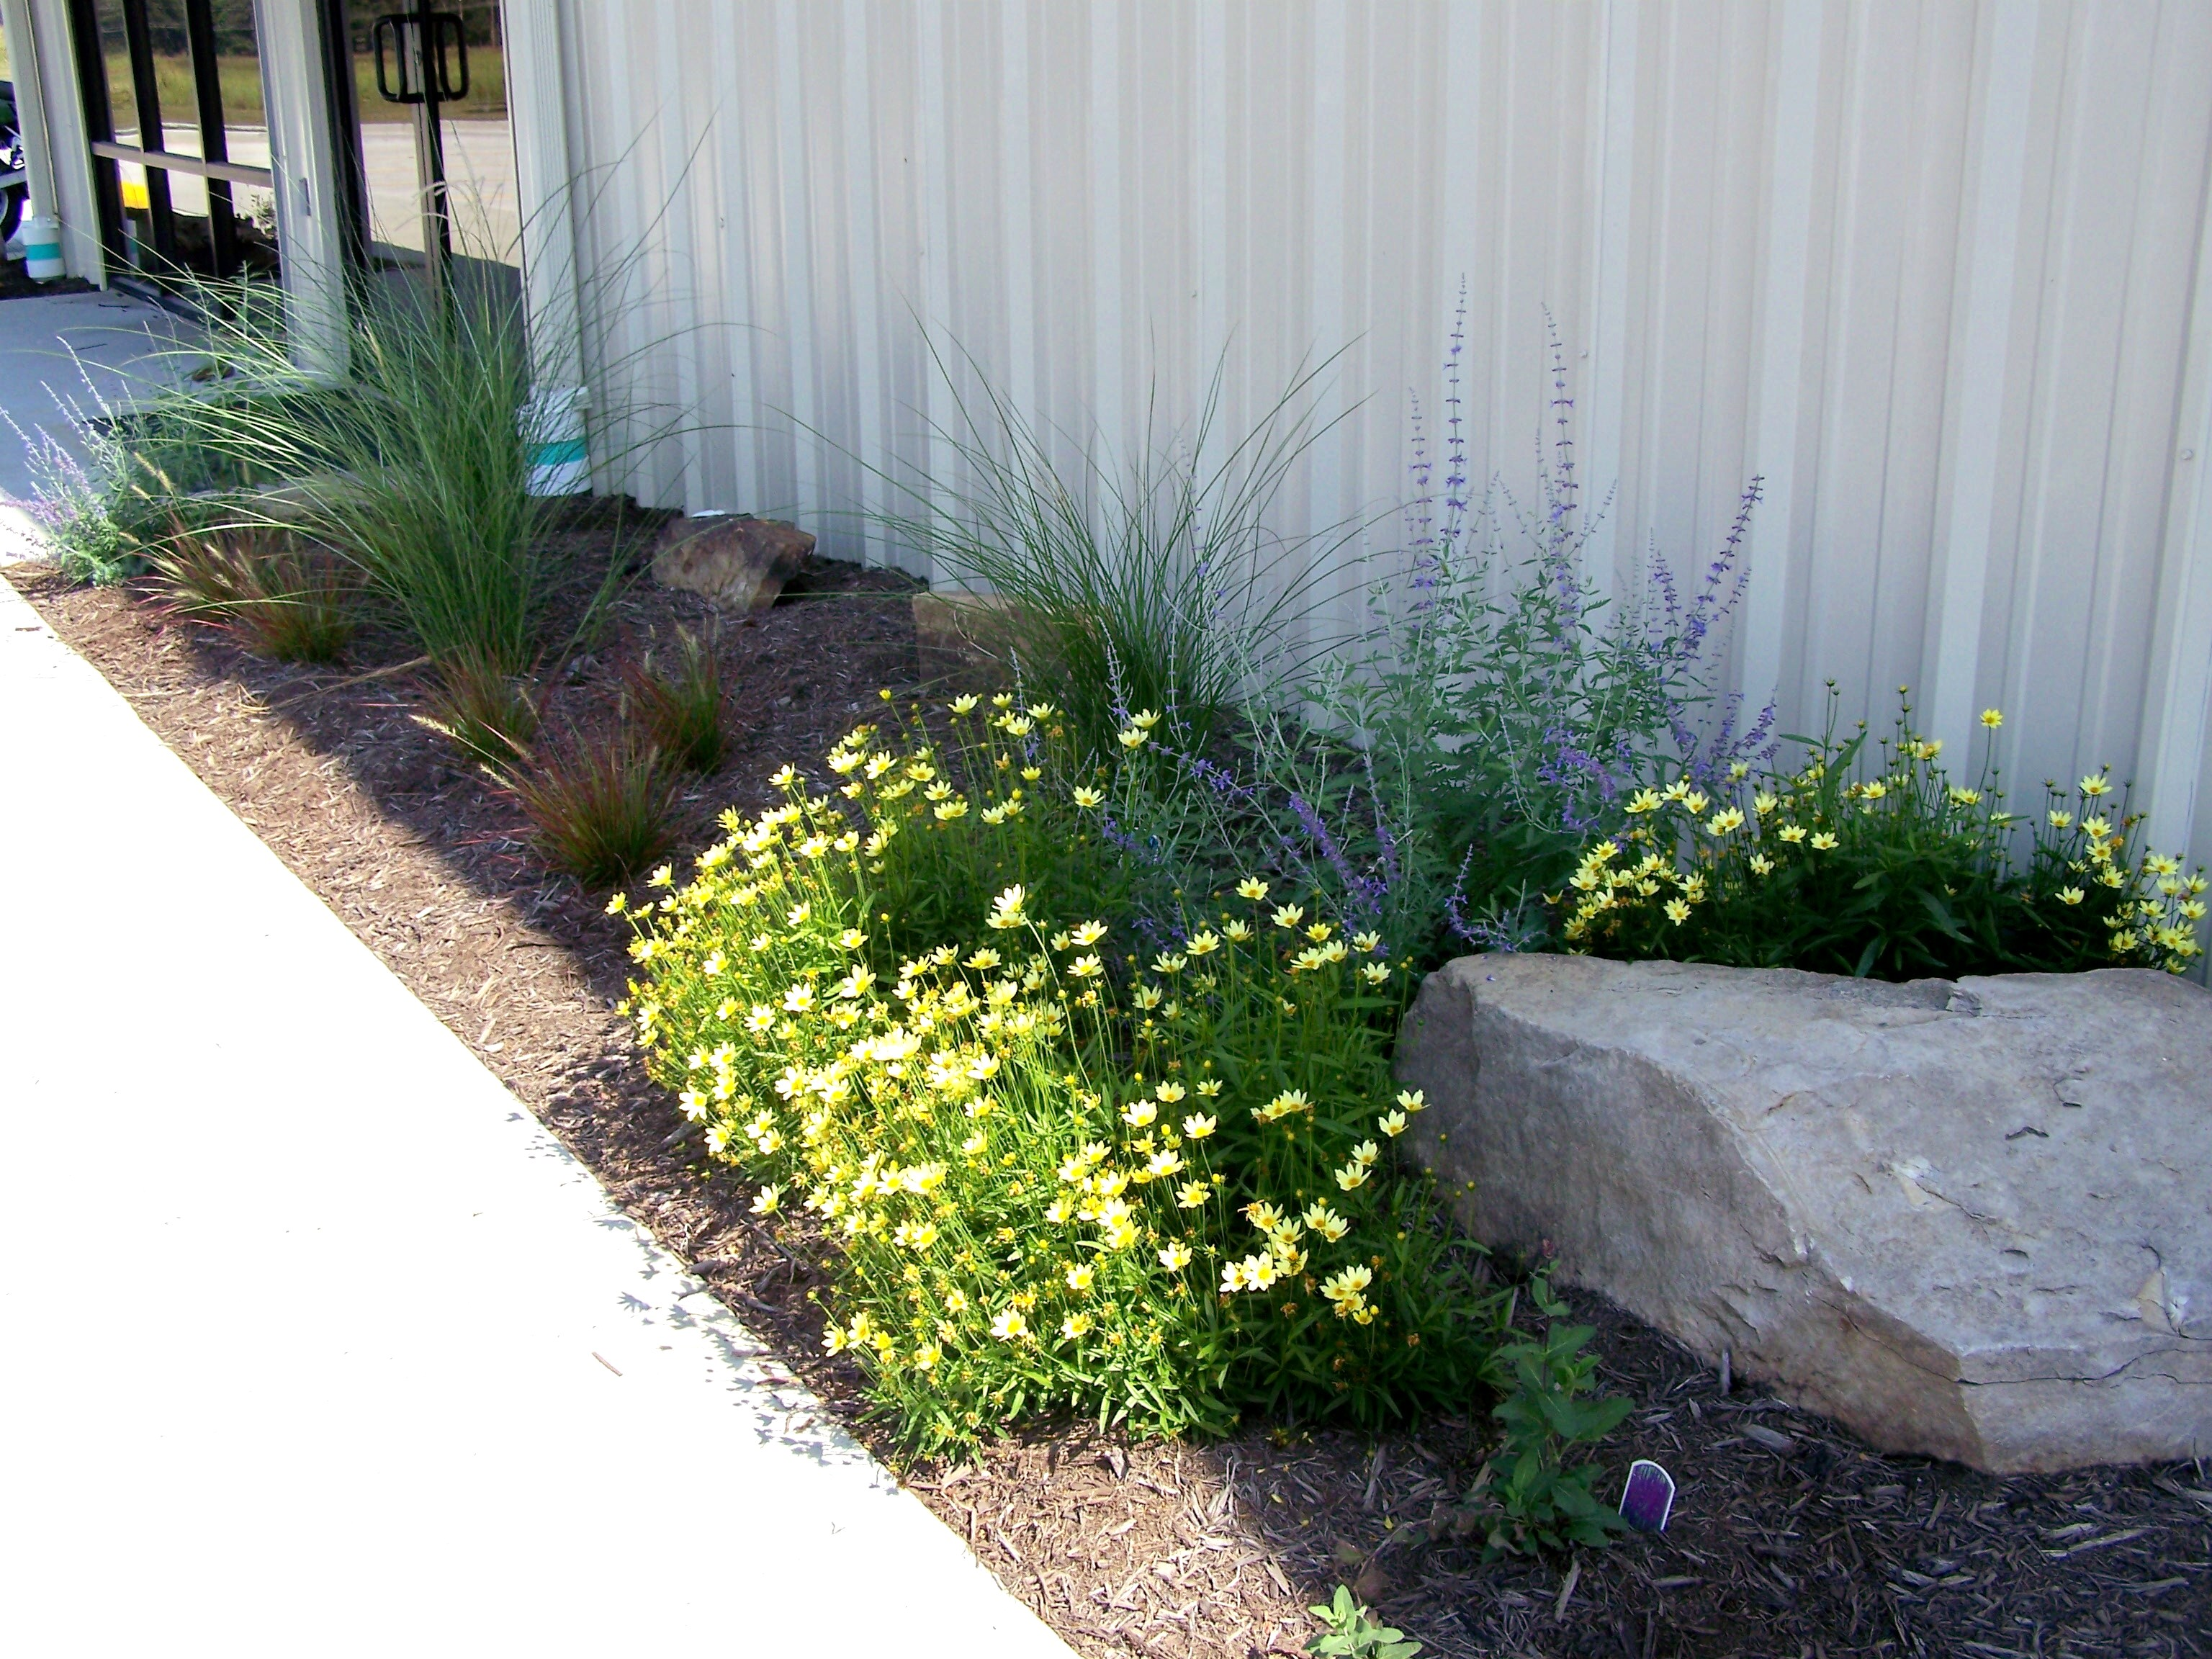
July 2011: Phase 1 completed. Drought-tolerant, deer resistant plants installed by a team of Lyon County Master Gardeners, Lyon County Park Department staff and Western Kentucky Correctional Complex inmates.

AFTER

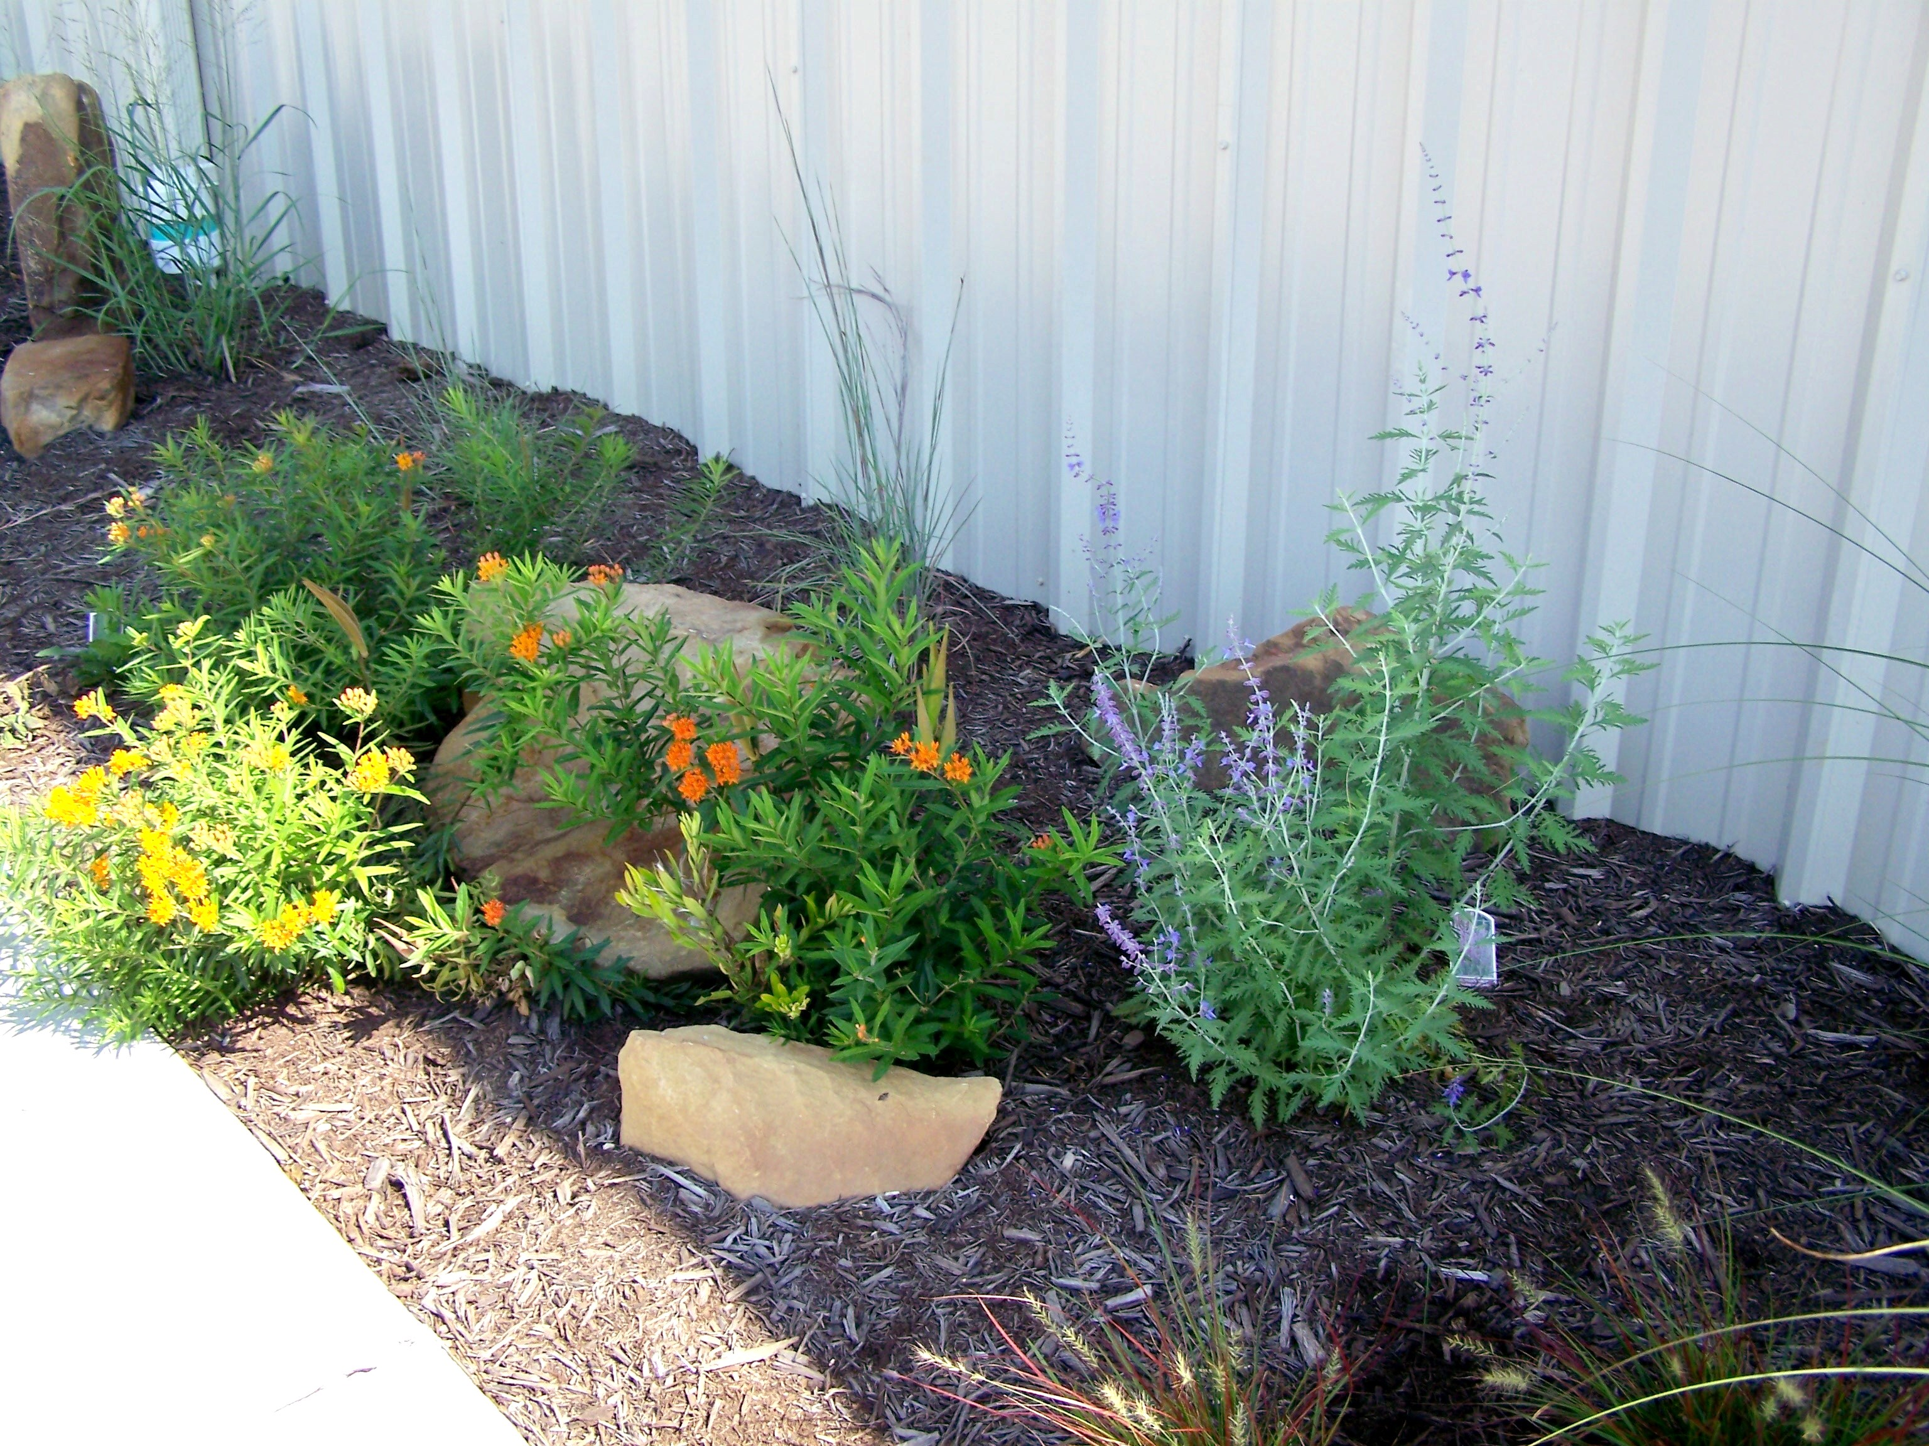
September 2011: Phase II completed.

AFTER

