NEW SCREE GARDEN FOR EDDYVILLE CITY PARK
By Moira Miller, Lyon County Master Gardener

On June 17 some of Lyon County’s latest graduating class of Master Gardeners teamed up to plant a scree garden in front of the Eddyville City Park Pavilion. The area is steeply sloped and covered in riprap. Riprap is not the most attractive ground cover but it does serve to hold the soil in place and prevent erosion. This is a perfect spot for a scree garden.

The word scree comes from the old Scottish word skridan, meaning an accumulation of loose stones or rocky debris lying on a slope, or at the base of a hill or cliff. What is the difference between scree and rock gardens? The scree is always on a slope. This makes it just right for ditches, around water features, storm shelters, decks, and transition areas from garden to woods. Some Lyon County residents live on Lake Barkley and have large boulders on their property. Again, a perfect spot for a scree.

Alpine plants are most typically associated with scree gardens, but any rock garden plants will work well. These types of plants require very little maintenance, once established, and very little water. They are drought tolerant and come in a variety of sizes and colors.

Scree gardens are wonderful for problem areas, and for people with little time for gardening. The plants thrive in poor soil. A mixture of garden soil, sand and gravel is all that is required. Choose pockets among the rocks, then fill with the soil mixture and position your plants. Water lightly every 3-4 days for the first month, thereafter water only in times of drought. Once a month or so check for weeds. A fertilizer may be needed once every 1-2 years. A very light application of 10-10-10 should suffice. Periodically clear the rocks of old plant debris, leaves etc.

It will take a little while before the plants mature, but the area in front of the pavilion will definitely be a sight to behold in the coming months. Following is a list of the perennial scree plants we used; Lavender, Hummingbird Mint, Siberian Stonecrop, Hens & Chicks, Blue Tears
Sedum, Oregon Stonecrop, Rock Thyme, Pterocephalus Perennis, Blue Moor Grass, Hedgehog Fescue, Fameflower, Wintergreen, and Blue Rug Juniper. Two yellow Knockout Rose bushes were added for height and color, as well as some Lariope.

Many thanks go to Mayor Judith Stone, Susan Fox, Mitchell Peeler and the new Master Gardeners for all their help and support on this project. Several other park projects are in the works and should be completed by the end of the year. If you are interested in becoming a Master Gardener please contact Susan Fox at the Lyon County Cooperative Extension Office 270-388-2341.

PHOTO (below) left to right: Susan Fox (Lyon County Extension Agent)
Mitchell Peeler (Summer Youth Worker)
Moira Miller (Master Gardener)
Cathy Turner (Master Gardener)
Karen Thacker (Master Gardener)
Larry Mansfield (Master Gardener)

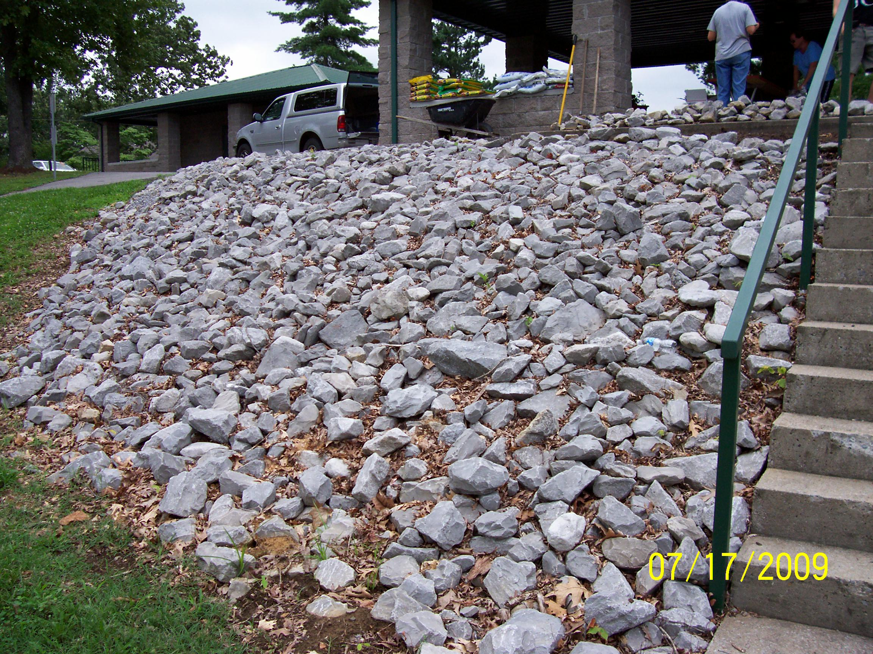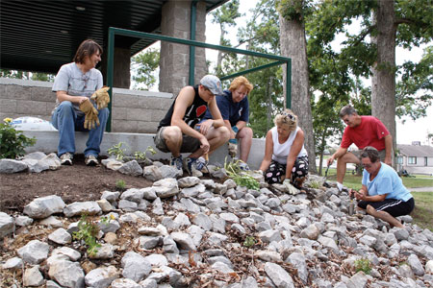
BEFORE TEAM AT WORK

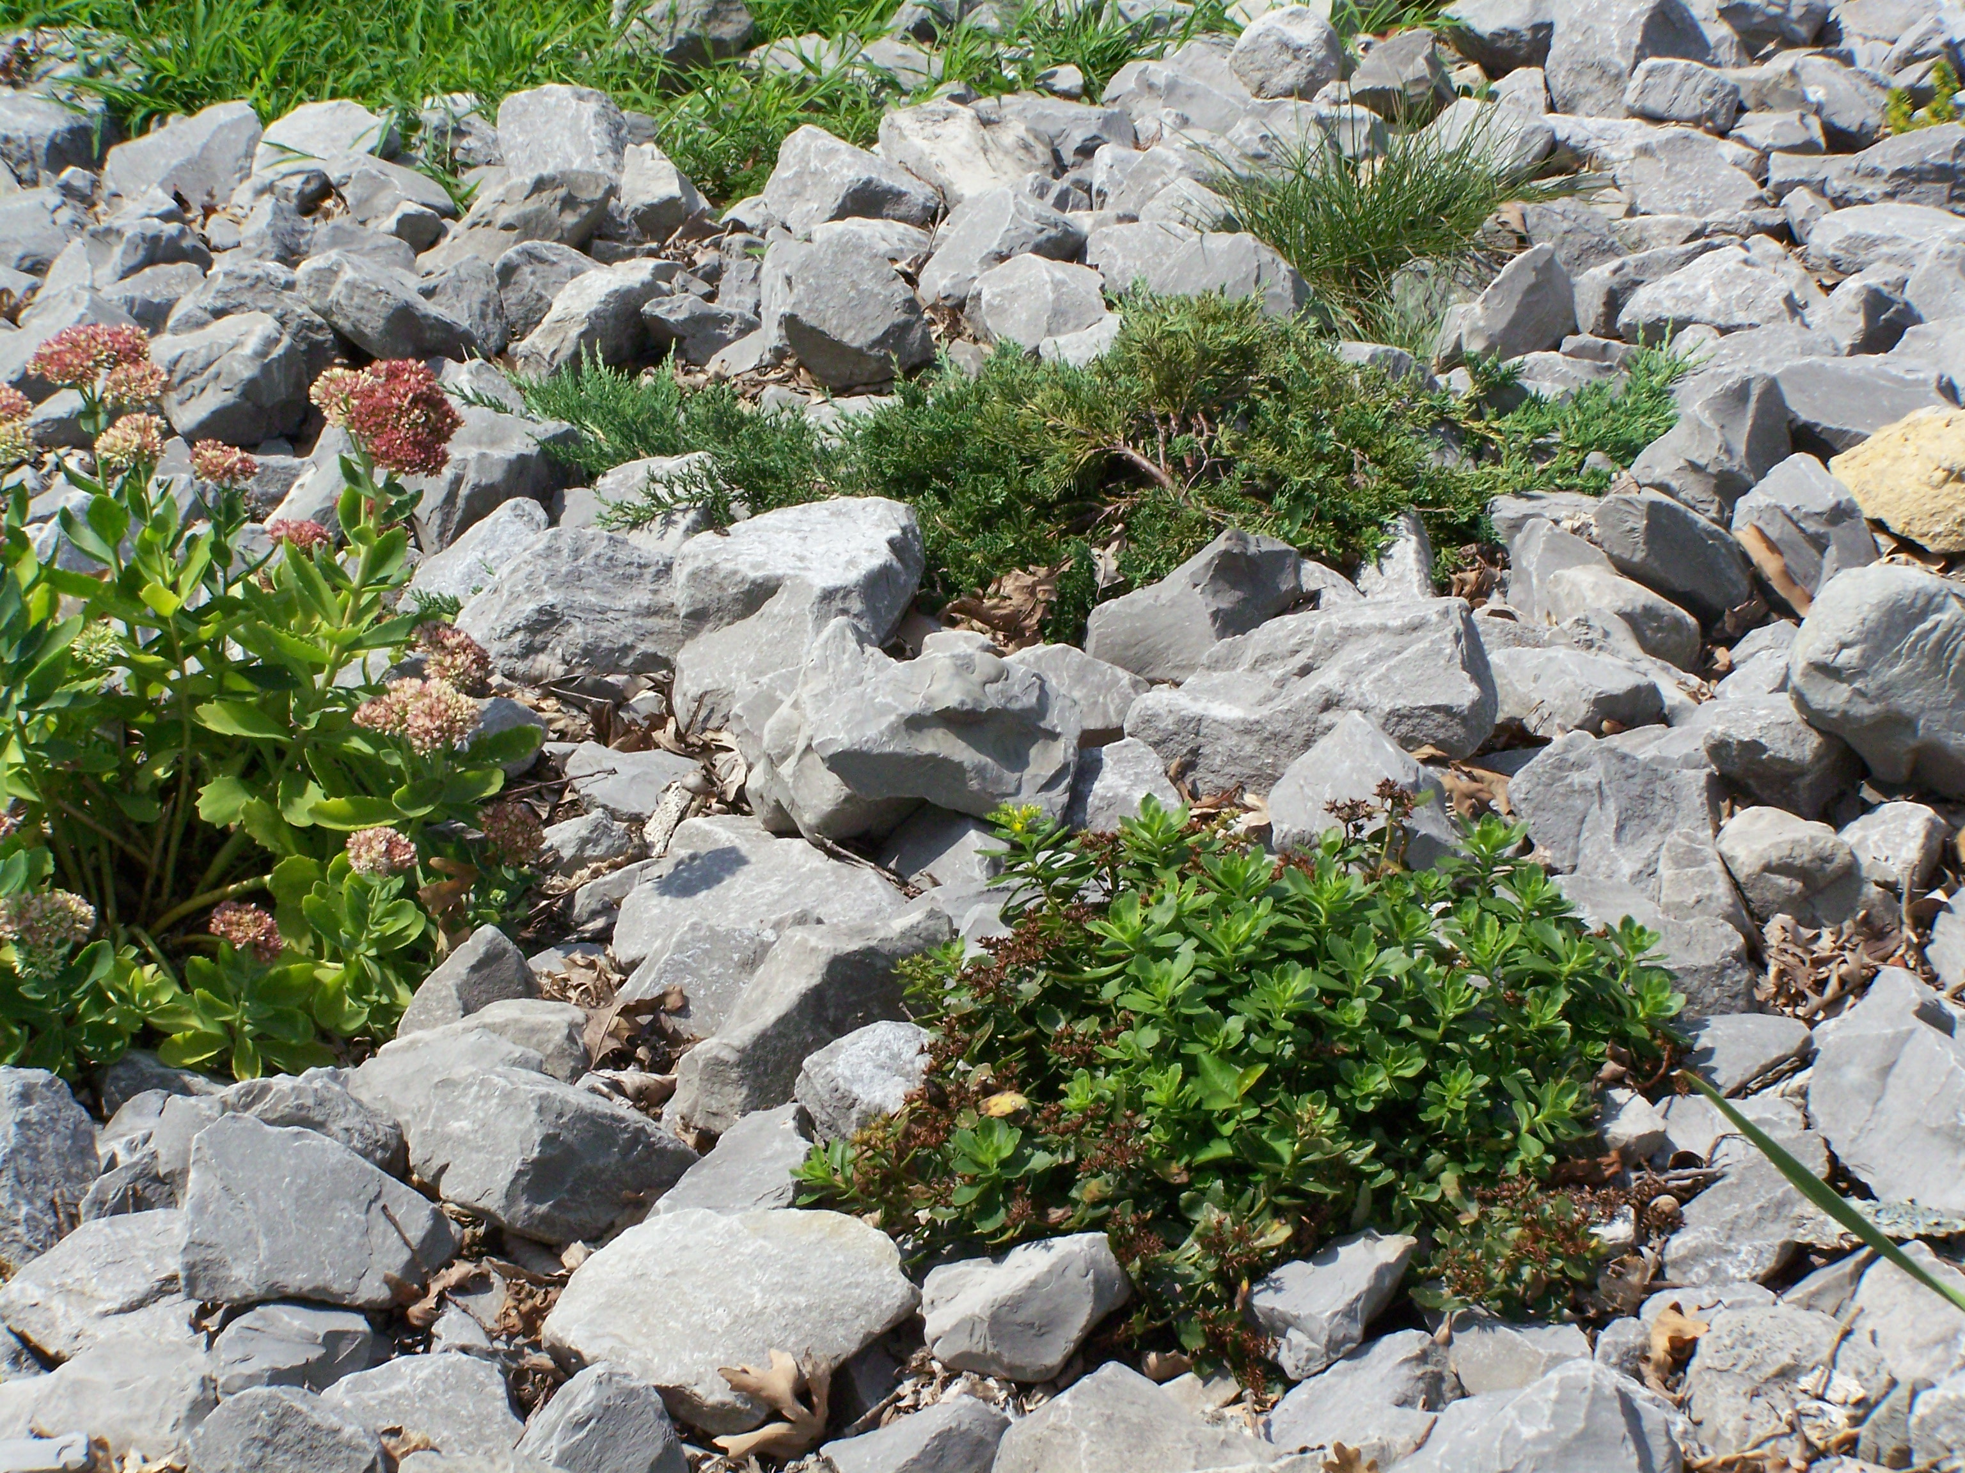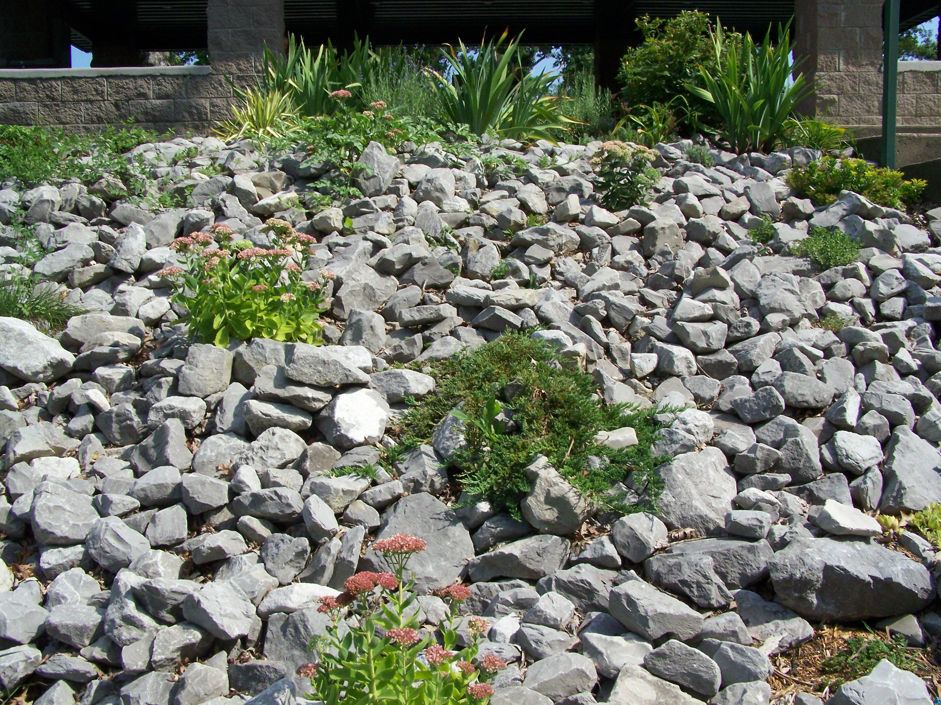
AFTER AFTER

