POND & WATER GARDEN PLANTS FOR WESTERN KY.
Moira Miller, Lyon County Master Gardener
Here are a few recommendations for pond and water garden plants that do well in this area.

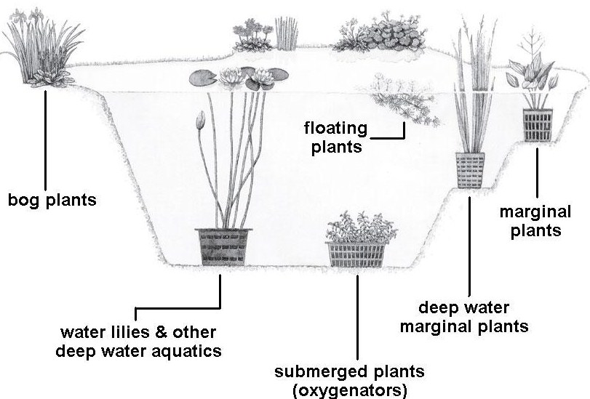

WATERLILIES
There are several hardy, perennial water lilies that do well in our area. Keep in mind the size of your pond in relation to the mature size of these plants. At some point in time you may have to divide the rhizomes.
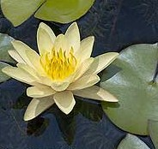
- Comanche (Nymphaea 'Comanche') Zones 3-11, planting depth 10-15” over the crown. Spreads 4-5 in diameter. New leaves are bronze, turning to green. Flowers are yellow-apricot to gold, changing to gold orange or deep orange. Plant in a 16” fabric pot, or a 16” x 7” plastic pot. Direct sun: 4-6 hrs.

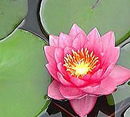

- James Brydon (Nymphaea 'James Brydon') Zones 3-11, planting depth 12-15” over the crown. Spreads 3-5 ft. in diameter. Leaves are bronzy green. Flowers are deep pinkish-red. Plant in a 16” fabric pot or, a 16” x 7” plastic pot. Direct sun: 4-6 hrs.

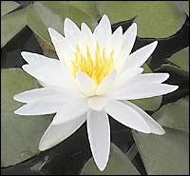

- Virginia (Nymphaea ‘Virginia’) Zones 3-11, planting depth 12-15” over the crown. Spreads 5-6 ft. in diameter. Leaves are green. Flowers are off-white and star-shaped. Plant in a 16” fabric pot or, a 16” x 7” plastic pot. Direct sun: 4-6 hrs.

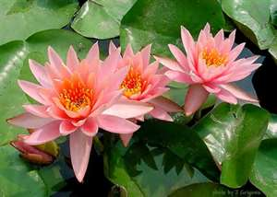
- Colorado (Nymphaea ‘Colorado’) Zones 4-11, planting depth 12-15” over the crown. Spreads 4-5 ft. in diameter. Leaves are green. Flowers are peach colored. Blooms late spring until frost. Plant in a 16” fabric pot or, a 16” x 7” plastic pot. Direct sun at least 6 hrs.

FLOATING PLANTS

If you don’t want water lilies, or are having trouble growing them, try some floating plants.
Floating plants are typically annuals in this area due to cold winters.
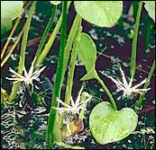

- Frog Bit (Hydrocharis morus-ranae) Zones 6-10, leaves are 1-1-1/2” across. Flowers are very small white, star-shaped. Plant spreads by runners.

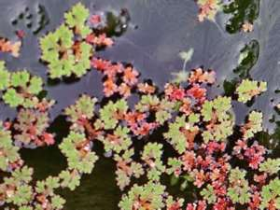
- Fairy Moss (Azolla sp.) Zones 6-11, can spread indefinitely. Koi love to nibble on the edges of this soft, fuzzy plant. Grows 1” high. Likes sun, part shade or full shade.

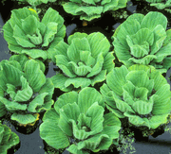
- Water Lettuce (Pistia stratoites) Zones 4-11. Tropical, free floating plant (an annual in our area). Velvety ribbed leaves form delicate, pale green rosettes. Resembles a cabbage plant. The leaves grow 8 - 10 in. long and 4 in. wide and produce plantlets that stretch out from the mother plant on slender stems. These can be separated and the older plants can be thinned out. If yellowing occurs the plants can be separated from the pond and fertilized. Excellent in shady ponds.

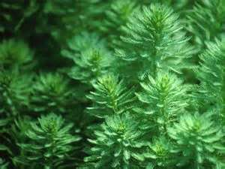
- Parrot Feathers (Myriophyllum aquaticum) Zones 4-11, Parrot's Feather's lushly textured green-blue foliage helps provide shade for the pond and fish. Provides a hiding place and spawning material for the pond inhabitants. Because of its capability of establishing itself in wet soil above the water, Parrot's Feather can be used in waterfall crevices, as well as along pond edges. It may be prone to frost damage, but winters well beneath ice.

MARGINAL/BOG PLANTS
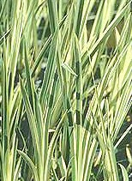
Most ponds have varying levels. Here are a few recommendations for the shallow end or ledge of your pond.

- Variegated Sweetflag (Acorus gramineus) Zones 4-11, grows 18-30”. Top of pot should be 4” below the surface. Grows in full sun to part shade. Vertical cream and green iris-like foliage. Plant in 14” fabric pot or 12 x 5” plastic pot.

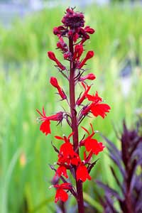

- Cardinal Flower (Lobelia cardinalis) Zones 5-11, grows 2-4 ft. Top of pot should be 3” below the surface. Grows in full sun to part shade. Have 1” red flowers mid to late summer. Before a hard frost, remove the pot and place it in a hole in the ground. Plant in 14” fabric pot or 12 x 5” plastic pot.

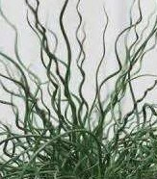
- Corkscrew Rush (Juncus effusus spiralis) Zones 3-8, grows 15-24”. Top of pot should be 6” below the surface. Grows in full sun to part shade. Thin green “leaves” grow in a spiral, they add a lot of interest and texture. Flowers are insignificant. Plant in 14” fabric pot or 12 x 5” plastic pot.

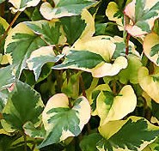

Chameleon Plant (Houttuynia cordata variegeta) Zones 5-11, grows 6-12”. Top of the pot should be 4” below the surface. Green foliage with red and cream highlights. White flowers in summer. Grows in full sun to part shade. Plant in 14” fabric pot or 12 x 5” plastic pot.

SUBMERGED PLANTS (Oxygenators)
These plants add oxygen to the water and help prevent the formation of algae.

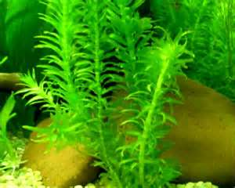
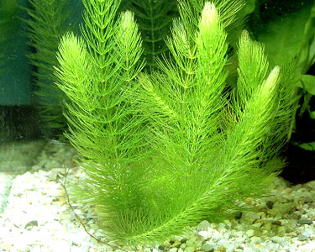
- Anacharis canadensis – Elodea - Usually sold in bunches. Can be planted in the pond by putting it in with your water lilies, lotus or bog plants. It can also be anchored with gravel or small stones in shallow water areas. White flowers grow on short stems on the water's surface throughout the summer. It is a good consumer of nitrate in the water and can grow rapidly to fill any niche.

- Hornwort (Ceratophyllum) Very useful in keeping water clean and free of excess algae. Because they never root, all of their nutrients are derived directly from the water. It provides egg scattering fish like Koi an outstanding spawning medium and a great hiding place for fish fry. Will grow either free floating or will become attached to the bottom of the pond.

Choosing the right plants will give you years of enjoyment. They will also give plenty of cover for fish such as goldfish and koi. Remember to clean plant debris from your pond regularly.
Note: Make sure any plants you select are not banned in Kentucky. Some plants can be invasive in our waterways and should not be released into other ponds, rivers or lakes.

For additional information check with your local library for books on this subject, or visit the many resources online such as www.davesgarden.com and the University of Kentucky’s Horticulture site at www.uky.edu/Ag/Horticulture/

Educational programs of the Kentucky Cooperative Extension Service serve all people regardless of race, color, age, sex, religion, disability, or national origin. Additional gardening information can be found at the Lyon County Master Gardener Association website http://lcmga.yolasite.com

Here are pictures of a pond I had in Evansville, IN. It was 8 ft. wide by 12 ft. long, with a waterfall. The shallow end was 18” deep sloping to 3-1/2 ft. deep. You can see cattails, floating lettuce, water lilies; and around the edges golden mop, ivy, and various sedum. It was stocked with goldfish and koi. The fish rested at the bottom of the deep end ALL WINTER without moving, or feeding. I had a pond heater in during the very cold months, so the pond didn’t ice over.


